**The Hand**

**1 Introduction**

This device, referred to as "The Hand," will respond to a digital signal and replicate hand movements. The initial hand design should be fairly basic, integrating only two or three degrees of motion.

**2 Initial Stages Design, Claw**

The image below depicts a possible design for "The Hand."

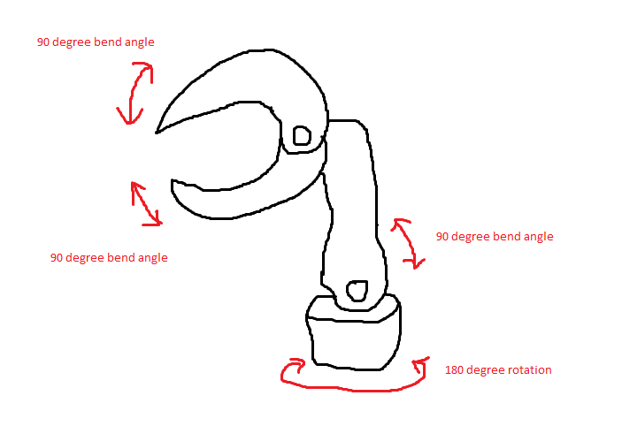

This design integrates four degrees of motion and is slightly more complicated than the design expected in Section 1. However, this design is able to pick up any object placed within a certain radius around the hand. The design acts as a claw.

To simplify this design, it is suggested that the 180 degree rotation specification be removed.

**3 Motor Control**

Basic motor control is done in the following fashion:

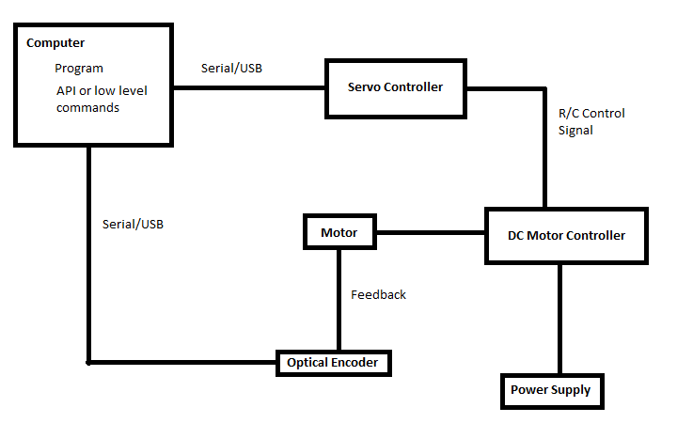

Courtesy of <http://www.youtube.com/watch?v=X4stWDy-bPA>

Most servo controllers and DC motor controllers are compatible, since they communicate via R/C signals.

**4 Definitions**

*DC Motor:* A DC motor is an electric motor that runs on direct current (DC) electricity.

*Motor Controller:* A motor controller is a device or group of devices that serves to govern in some predetermined manner the performance of an electric motor.

*Optical Encoder:* A linear or angular position feedback device using light fringes to develop position information.

*Servo Controlled:* Controlled by a driving signal which is determined by the error between the mechanism's present position and the desired output position.

*Servo Motor:* A motor that controls the action of the mechanical device in a servomechanism.

*Servomechanism:* A powered mechanism producing motion or forces at a higher level of energy than the input level. For example, brakes and steering of large motor vehicles, especially where feedback is employed to make the control automatic.